Dataset
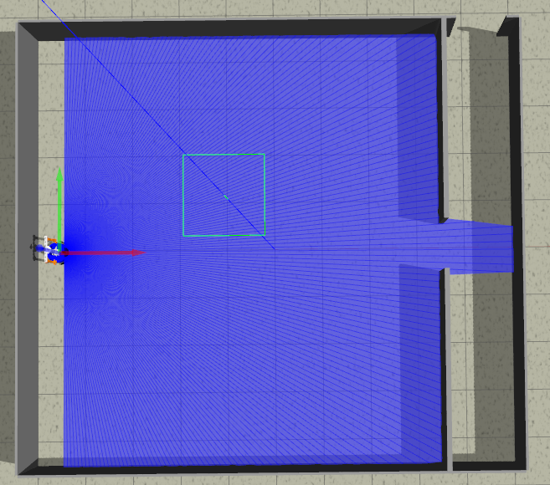
rnd_room_c2_01:
samples
1)
linea recta a puerta 7.5m (x3) (-4.6 0.0 0.0) to (3.3, 0.0, 0.0)
files: data_from_path_2025-02-26_10-08-23 to data_from_path_2025-02-26_10-13-12

2)
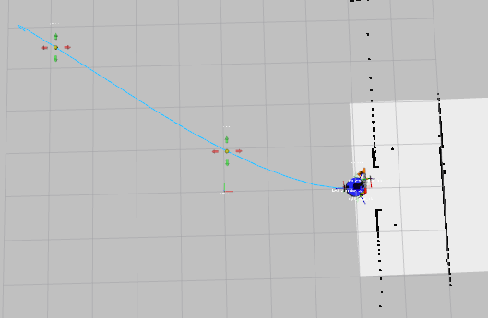
esq inf izq a puerta 8.9m (x3) (-4.6 3.9 0.0) to (3.3, 0.0, 0.0)
files: data_from_path_2025-02-26_10-42-09 to data_from_path_2025-02-26_10-49-34

3)
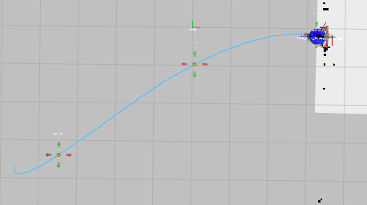
esq inf der a puerta 8.9m (x3) (-4.6 -3.9 0.0) to (3.3, 0.0, 0.0)
files: data_from_path_2025-02-26_10-52-22 to data_from_path_2025-02-26_10-55-57

4)
inea recta a puerta 7.5m (x3) (-4.6 0.0 PI) to (3.3, 0.0, 0.0)
files: data_from_path_2025-02-26_11-06-28 to data_from_path_2025-02-26_11-07-46

5)
esq inf izq a puerta 8.9m (x3) (-4.6 3.9 PI) to (3.3, 0.0, 0.0)
files: data_from_path_2025-02-26_11-12-09 to data_from_path_2025-02-26_11-14-55

6)
esq inf der a puerta 8.9m (x3) (-4.6 3.9 PI) to (3.3, 0.0, 0.0)
files: data_from_path_2025-02-26_11-20-08 to data_from_path_2025-02-26_11-21-03

7)
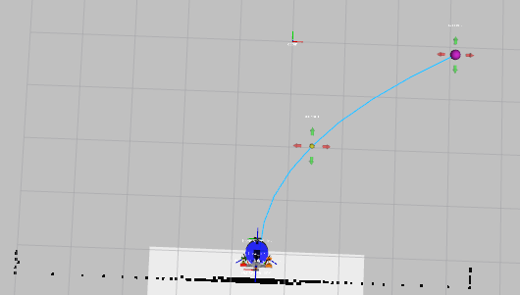
centro der a puerta 5.3m (x3) (-0.5 -3.9 -1.57075) to (3.3, 0.0, 0.0)
files: data_from_path_2025-02-26_11-26-56 to data_from_path_2025-02-26_11-27-57

8)
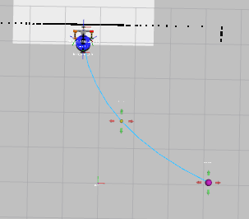
centro izq a puerta 5.3m (x3) (-0.5 3.9 1.57075) to (3.3, 0.0, 0.0)
files: data_from_path_2025-02-26_11-30-54 to data_from_path_2025-02-26_11-33-18

9)
centro izq a puerta 5.3m (x3) (-0.5 3.9 -1.57075) to (3.3, 0.0, 0.0)
files: data_from_path_2025-02-26_11-36-07 to data_from_path_2025-02-26_11-37-02

10)
entro der a puerta 5.3m (x3) (-0.5 -3.9 1.57075) to (3.3, 0.0, 0.0)
files: data_from_path_2025-02-26_11-39-55 to data_from_path_2025-02-26_11-41-22
11)
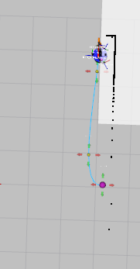
esq sup izq a puerta 3.8m (x2) (3 3.9 0) to (3.3, 0.0, 0.0)
files: data_from_path_2025-02-26_11-45-43 to data_from_path_2025-02-26_11-46-43

12)
esq sup izq a puerta 3.8m (x2) (3 3.9 1.57075) to (3.3, 0.0, 0.0)
files: data_from_path_2025-02-26_11-49-00 to data_from_path_2025-02-26_11-49-24

13)
esq sup izq a puerta 3.8m (x2) (3 3.9 -1.57075) to (3.3, 0.0, 0.0)
files: data_from_path_2025-02-26_11-51-43 to data_from_path_2025-02-26_11-52-07

14)
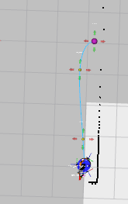
esq sup der a puerta 3.8m (x2) (3 -3.9 0) to (3.3, 0.0, 0.0)
files: data_from_path_2025-02-26_11-55-20 to data_from_path_2025-02-26_11-56-55

15)
esq sup izq a puerta 3.8m (x2) (3 -3.9 1.57075) to (3.3, 0.0, 0.0)
files: data_from_path_2025-02-26_11-58-59 to data_from_path_2025-02-26_11-59-27

16)
esq sup izq a puerta 3.8m (x2) (3 -3.9 -1.57075) to (3.3, 0.0, 0.0)
files: data_from_path_2025-02-26_12-00-59 to data_from_path_2025-02-26_12-01-23

17)
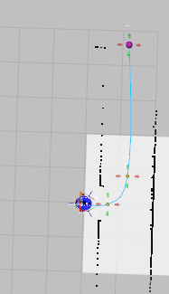
puerta a puerta 4.1m (x3) (3 0 0) to (4.18, 4.6, 0.0)
files: data_from_path_2025-02-26_12-08-51 to data_from_path_2025-02-26_12-11-02

18)
puerta a puerta 4.1m (x3) (3 0 PI) to (4.18, 4.6, 0.0)
files: data_from_path_2025-02-26_12-12-44 to data_from_path_2025-02-26_12-13-27

-----
Mirror
-----

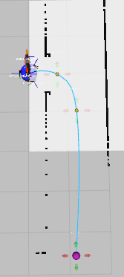
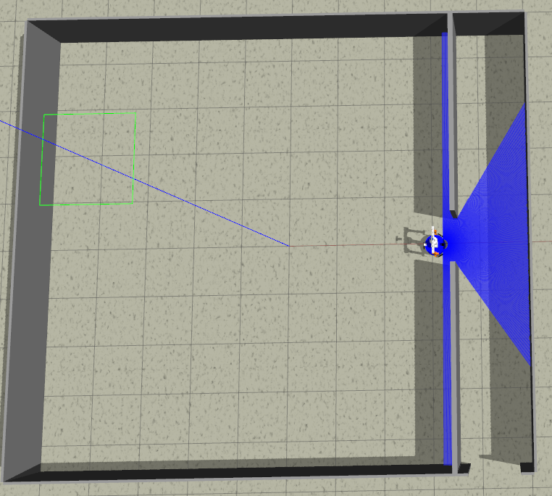
19)
puerta a puerta 4.1m (x3) (3 0 PI) to (4.18, -4.6, 0.0)
files: data_from_path_2025-02-26_12-24-17 to data_from_path_2025-02-26_12-27-06

